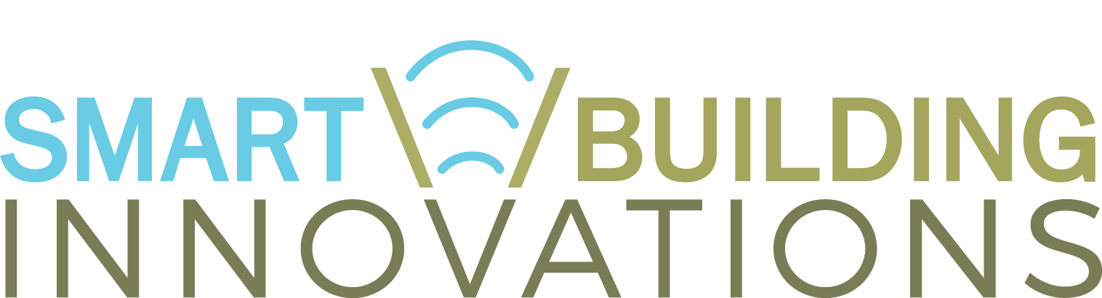
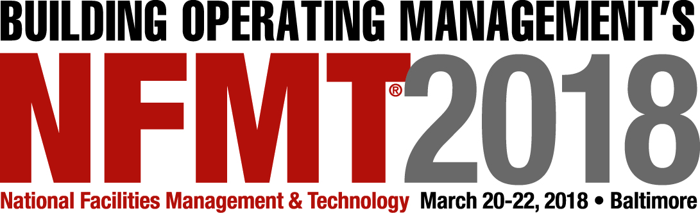

Date
Dear <Manager>:
I’m requesting approval to attend NFMT and SBIC, taking place March 20-22, 2018 at the Baltimore Convention Center in Baltimore, MD. The training seminars and exhibiting companies make attending a major benefit as the event aligns directly to priorities in our department: (insert priorities here).
Unlike other FM conferences which charge up to $1,795 to attend, registration for NFMT and SBIC is free. In three days, I will experience:
- Over 125 Facilities Management Educational Sessions
- Up to 18 Hours of Continuing Educational Units
- New FM Technologies and Solutions from more than 500 of the nation’s top-tier companies
- Opening day Networking Party with complimentary appetizers and spirits
- Numerous one-on-one Networking with over 5,000 facilities managers
Topic Highlights Include:
- How to Align with Corporate Strategies Through Data Transparency
- Energy Management Strategies and Opportunities
- The ROI of Technology in the Workplace
- How Do You Know When it is Time to Re-Roof?
- What LEED v4 Commissioning Means to You
I am seeking approval for travel expenses to attend. NFMT and SBIC’s free registration includes networking activities, educational sessions and entry into the exhibit hall. I will also receive access to the conference proceedings after the event takes place. Here is my proposed expense list:
Airfare: $(xxx)
Transportation: $(xxx)
Hotel: $(xxx)
Meals: $(xxx)
Total: $(xxx)
My attendance will benefit the entire team as I plan on sharing a post-event report to relay learnings, recommendations and suggested action items. I am requesting the opportunity to review materials with you and discuss how we can leverage them for further training of our team.
Thank you for your consideration and I look forward to hearing back from you.

Sincerely,

First Name Last Name
Title, Department
Organization

