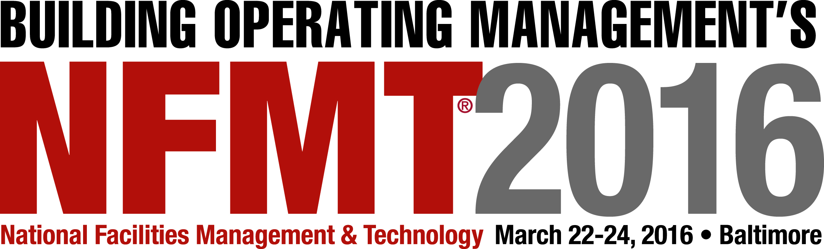

NFMT 2016 • Speaker Agreement

This letter is an agreement between _______________________________ (Speaker) and Trade Press Media Group, LLC and ROC Exhibitions, LLC (NFMT) for services to be rendered by Speaker as an instructor at NFMT 2015 Conference and Expo being held from March 22-24, 2016 at the Baltimore Convention Center, Baltimore, MD.

SPEAKER COMMITMENTS:
Speaker agrees to prepare and present technical content and instruction at the conference for a 50-minute conference session as described in the following sections.

WORKSHOP HANDOUT MATERIAL
It is recommended that handouts be produced with as simple a visual layout as possible, with dark large type on a white or light‐colored background. This will ensure that the content of the slides will be visible from the back of the room. All conference materials will be available for download at the time of the conference. Please include any white papers, tools, bibliographies, links, or other materials that Speaker thinks may be pertinent or add value to the presentation. They will be included on the website if practicable. By signing this agreement the speaker authorizes NFMT to duplicate and distribute these presentation materials.

Deadline: Handouts are due by Friday, February 26, 2016. Handouts are required for each conference session and must be reviewed by NFMT prior to their distribution online. Please contact the Education Program Manager before the deadline if you need an extension.

Handout Submission: All handouts must be submitted to NFMT in electronic format in one of 2 ways: 1) Via email to email address 2) Via Mail on CD to the NFMT 2016 address.

Copyright Material: Copyright material and material duplicated from publications are unacceptable as handouts. Should copyright material be required, you must obtain written permission from the respective publisher and author. Authorization letters must be on file in the NFMT office. NFMT will not reproduce copyrighted material without appropriate release documentation.

NFMT 2016 POLICIES
Speaker Substitutions: NFMT does not allow speaker substitution without the consent of the NFMT Director of Education, Amy Brown. If a scenario arises causing the request of a substitute the speaker agrees to contact the Director of Education as soon as possible to discuss a solution.

Speaker Cancellations: If a speaker is forced to cancel the speaker agrees to contact the NFMT Education Program Manager, Amy Brown, as soon as possible. The speaker agrees to assist NFMT in identifying and find a substitute for the workshop or seminar. In addition the speaker agrees to provide their handout for use by the replacement speaker if needed.
Session Recording: By signing this agreement the speaker authorizes NFMT to record, duplicate, and distribute any portion of their participation in the NFMT 2016 Conference and Expo. In addition the speaker waives any and all claims resulting from the recording, duplicating, and sales of the aforesaid.
Photographs: By signing this agreement the speaker authorizes NFMT 2016 to use photographed images taken during the conference in promotional materials.

NFMT 2013 COMMITMENTS:
A/V: NFMT 2016 will arrange for and provide the necessary power and audio/visual support for presentations. This support will consist of: one (1) lapel microphone; one (1) LCD projector and screen; one (1) PC laptop computer; and a basic sound system. Any additional audio/visual equipment must be requested in writing by Friday, February 5. NFMT will make a best‐effort attempt to comply with special requests, but cannot guarantee success.

By signing and returning this agreement, Speaker acknowledges that he/she has read, understood, and agrees to be bound by the policies set forth in this agreement. If Speaker violates or fails to comply with any of these policies, the NFMT management will take appropriate actions and may rescind the speaking opportunity or future opportunities.

SIGNATURES: By signing this agreement, all parties affirm that they understand its terms and consent to be bound by them in their entirety.

SPEAKER:

Signature _____________________________________________________________________________

Date_________________________________________________________________________________

Printed Name__________________________________________________________________________

The Speaker Agreement is due on Friday February 5, 2016.

Please return signed agreement to:
Amy Brown
Email: amy.brown@tradepress.com
Fax: 414-228-1134
Or Mail:
Trade Press Media Group
2100 West Florist Ave
Milwaukee, WI 53209

